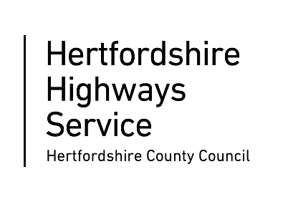

We’re coming to improve your area and need your help.


When and where we’ll be working
Where can you find information?
Please refer to the yellow signboards on your street to see the exact dates, timings and permit number, including any date changes. You can also visit One.Network online.

Do you need a hand?
If you have any special access requirements, please contact EST on 08442253336 or the Customer Service Centre on 0300 123 4047 or email us at cschighways@Hertfordshire.gov.uk

What: Micro Surfacing works
Where: High Street, Markyate
Dates and times: Thursday 17 September to Saturday 19 September. 9:30am to 3pm.
How: Road Closure
How does this affect you?
Parking and access: To allow us to come and do these improvement works we’ll need to restrict parking temporarily. If you need to use your vehicle, please move it outside the works area shown on this letter, at least 30 minutes before we are due to start working.

Vehicles may not be allowed access during the works, except for emergency vehicles. Please speak to the on-site team on the day who will be able to advise on access or contact the contractor.

Weather: Works are weather dependent and may be postponed. We apologise if works don’t start on time in these instances.

Affected bus services: Details of any disruptions to bus services can be found at www.intalink.org.uk/timetables (search for your service). If you're unable to find this information, please call our customer service centre on 0300 123 4047.

Map of the area we are working in
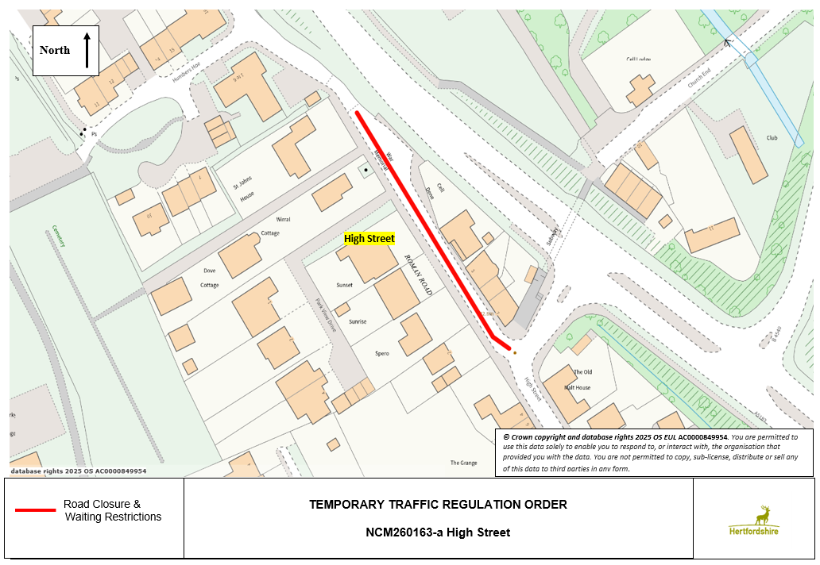
Works Permit Number: MICRO-CWY260163-1. You can use this permit number on One.Network.

